CREATE & CONFIGURE IBM CLOUD SERVICES

CREATE A DATABASE IN CLOUDANT DB

Date | 08 NOV 2022
Team ID | PNT2022TMID07561
Project name | Personal assistance for senior who are self- reliant

CLOUDANT SERVICE:
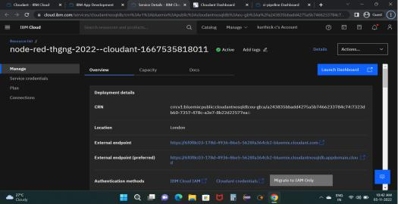

CREATION STATUS: ACTIVE
SERVICE CREDENTIALS:
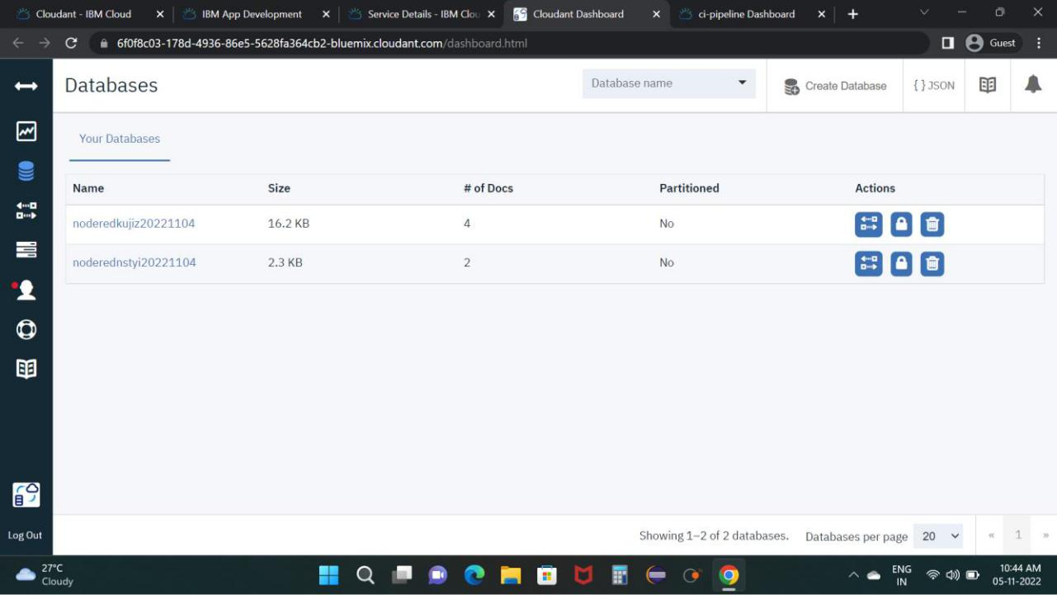

CREDENTIALS: GENERATED

